**House Price Prediction In Metropolitan Areas Of India**

House price prediction in a metropolitan city in India is a valuable solution for potential home buyers, real estate agents, and investors. By leveraging historical sales data, property details, and location-specific information, a predictive model can accurately estimate house prices. The model's scalability, real-time updates, user-friendly interface, and transparency ensure it meets the needs of stakeholders. Integration capability, data privacy, and cost-effectiveness are also important considerations. By addressing these requirements, the prediction model provides reliable insights, empowering stakeholders to make informed decisions in the fast-paced real estate market.

PROJECT DONE BY :

K. NAVYA VARSHINI [TEAM LEADER]

K. PRUDHVIRAJ [TEAM MEMBER]

K GEETHA [TEAM MEMBER]

M.SHILPA [TEAM MEMBER]

M.SAMPATH RAJU [TEAM MEMBER]

TEAM ID : LTVIP2024TMID11383

**FLOW OF THE PROJECT ;**

To accomplish this, we have to complete all the activities listed below,

* Define Problem / Problem Understanding
  + Specify the business problem
  + Business requirements
  + Literature Survey
  + Social or Business Impact.
* Data Collection & Extraction from Database
  + Collect the dataset,
  + Storing Data in DB
  + Perform SQL Operations
  + Connect DB with Tableau
* Data Preparation
* Prepare the Data for Visualization
* Data Visualizations
  + Number of Unique Visualizations
* Dashboard
  + Responsive and Design of Dashboard
* Story
  + Number of Scenes of Story
* Performance Testing
  + Amount of Data Rendered to DB ‘
  + Utilization of Data Filters
  + Number of Calculation Fields
  + Number of Visualizations/ Graphs
* Web Integration
  + Dashboard and Story embed with UI With Flask
* Project Demonstration & Documentation
  + Record explanation Video for project end to end solution
  + Project Documentation-Step by step project development procedure

1. DATA COLLECTION AND DATA EXTRACTION FROM DATABASE:

Data collection is the process of gathering and measuring information on variables of interest is an established systematic fashion that enables one to answer stated research questions , test hypotheses , and evaluate outcomes and generate insights from the data.

Activity 1 : COLLECT THE DATASET:

We have downloaded the dataset from the link given in the apsche smartinternz login.

Activity 2 : UNDERSTANDING THE DATA :

Data contains all the meta information regarding the coloumns described in the csv files .

2.DATA PREPARATION :

Data preparation is the process of preparing raw data so that it is suitable for further processing and analysis.

**Prepare The Data For Visualization :**

Preparing the data for visualization involves cleaning the data to remove irrelevant or missing data, transforming the data into a format that can be easily visualized, exploring the data to identify patterns and trends, filtering the data to focus on specific subsets of data, preparing the data for visualization software, and ensuring the data is accurate and complete. This process helps to make the data easily understandable and ready for creating visualizations to gain insights into performance and efficiency.

### 3. Data Visualization

Data visualization is the process of creating graphical representations of data to help people understand and explore the information. The goal of data visualization is to make complex data sets more accessible, intuitive, and easier to interpret. By using visual elements such as charts, graphs, and maps, data visualizations can help people quickly identify patterns, trends, and outliers in the data.

**No Of Unique Visualizations**

The number of unique visualizations that can be created with a given dataset. Some common types of visualizations that can be used to analyze the performance and efficiency of Radisson Hotels include bar charts, line charts, heat maps, scatter plots, pie charts, Maps etc. These visualizations can be used to compare performance, track changes over time, show distribution, relationships between variables, breakdown of revenue and customer demographics, workload, resource allocation and location of hotels.

THE CHARTS WE HAVE USED :

* + 1. Bar chart
    2. Pie chart
    3. Maps
    4. Donut chart
    5. Heat map
    6. Packed bubbles
    7. Horizontal bars
    8. Circle chart

1. PIE CHART :

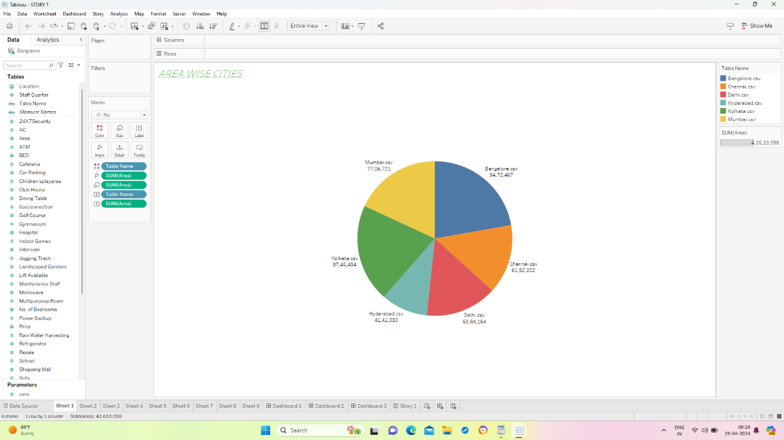

1. MAPS :

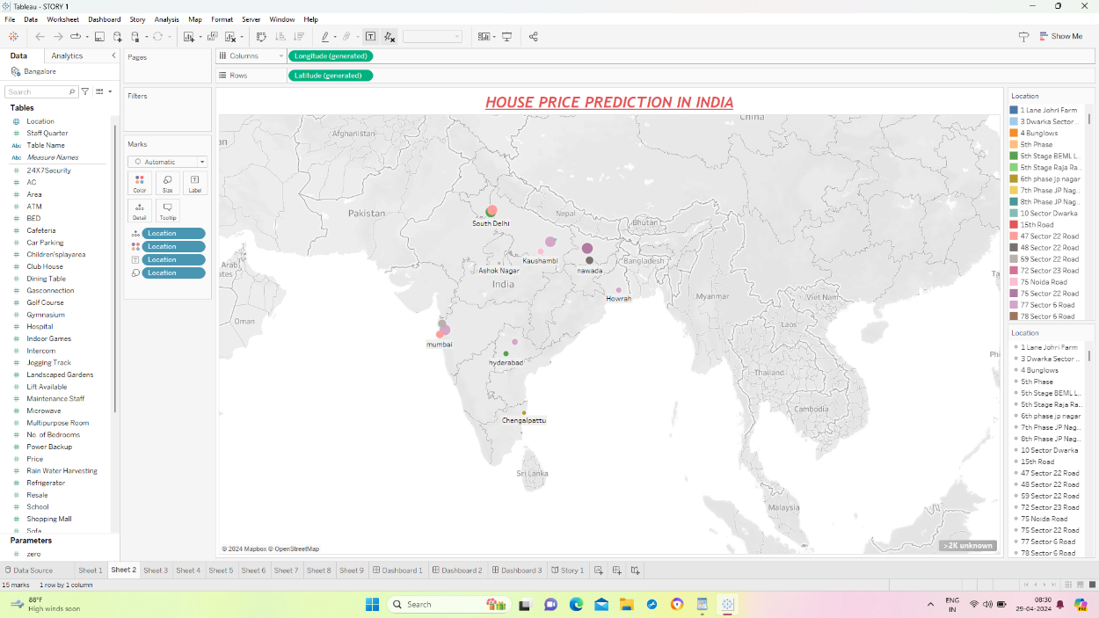

1. HEAT MAP :

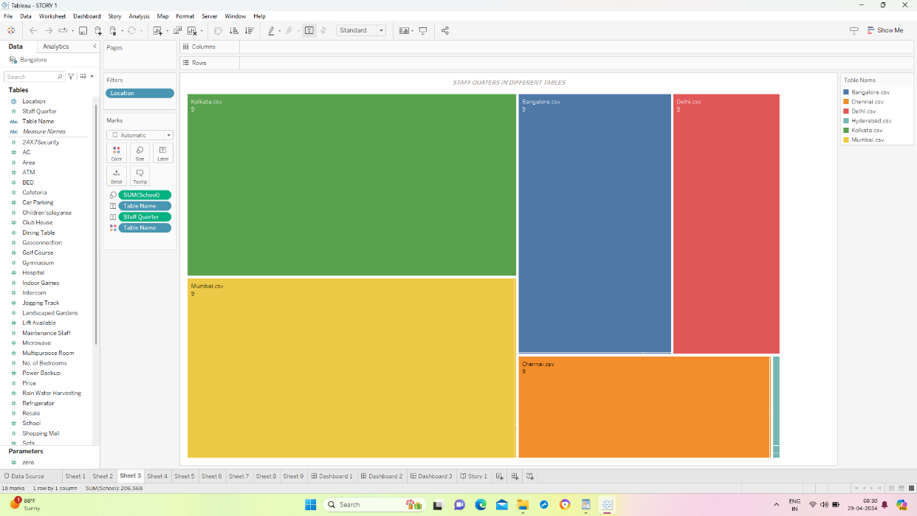

1. PACKED BUBBLES :

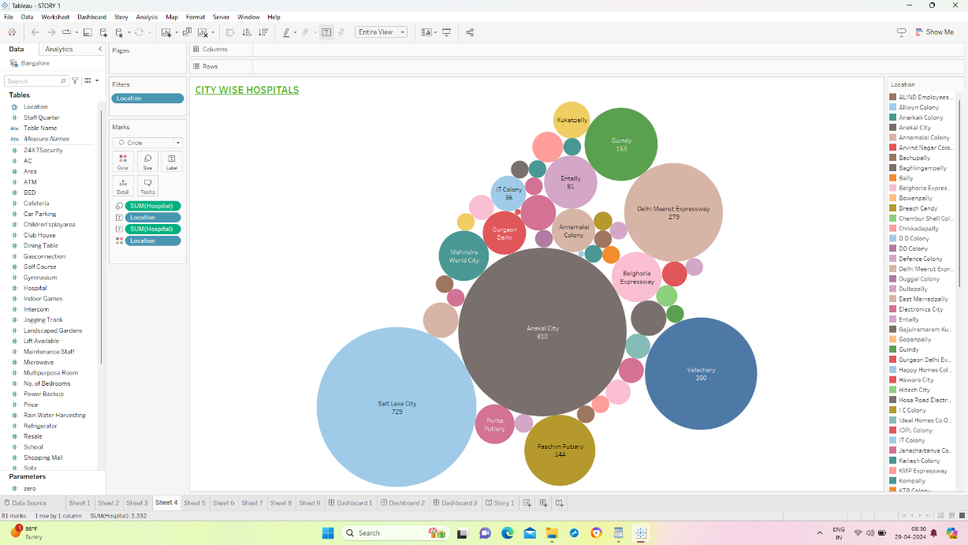

1. HORIZONTAL BAR CHART :

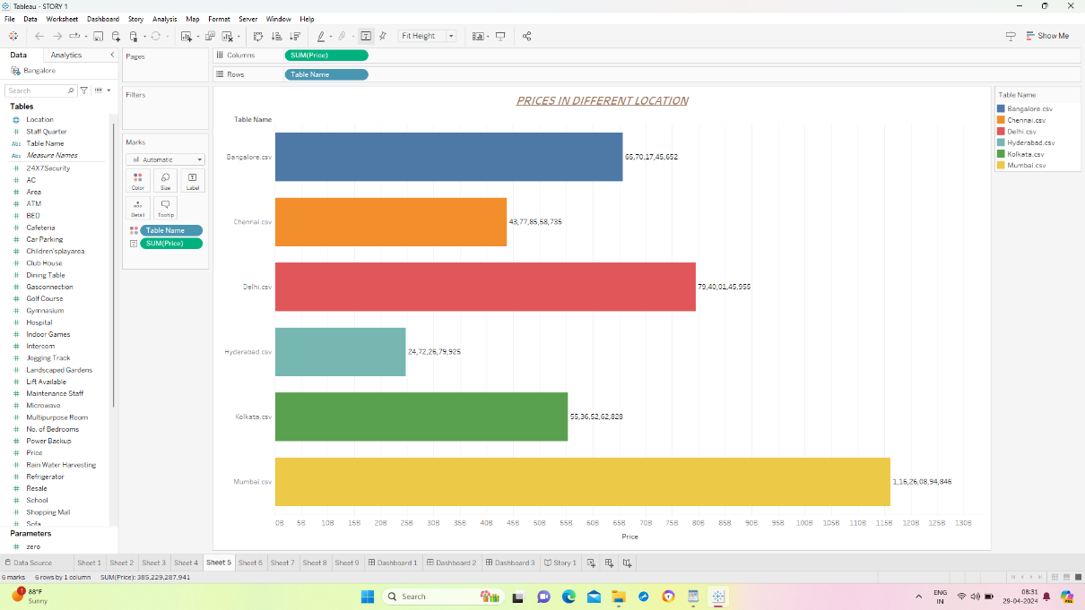

1. BAR CHART :

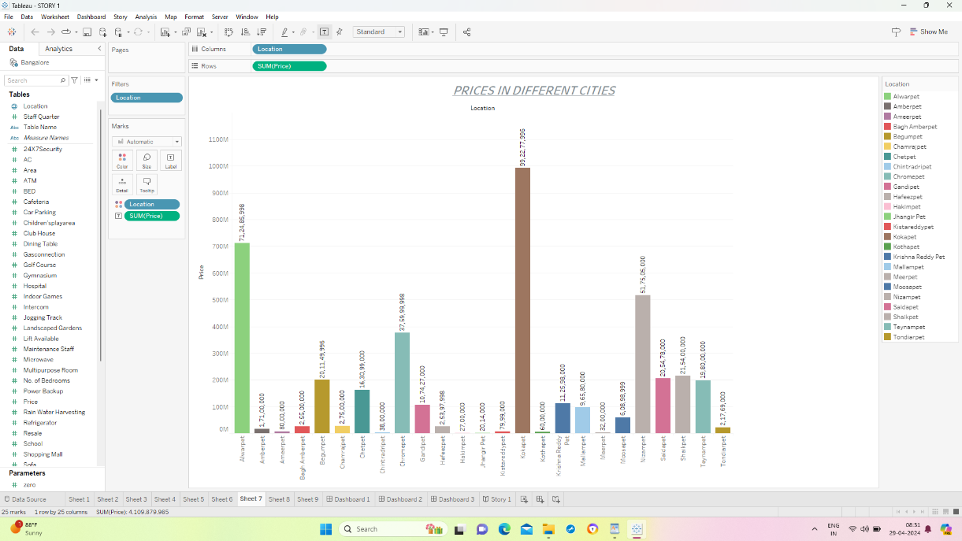

1. DONUT CHART :

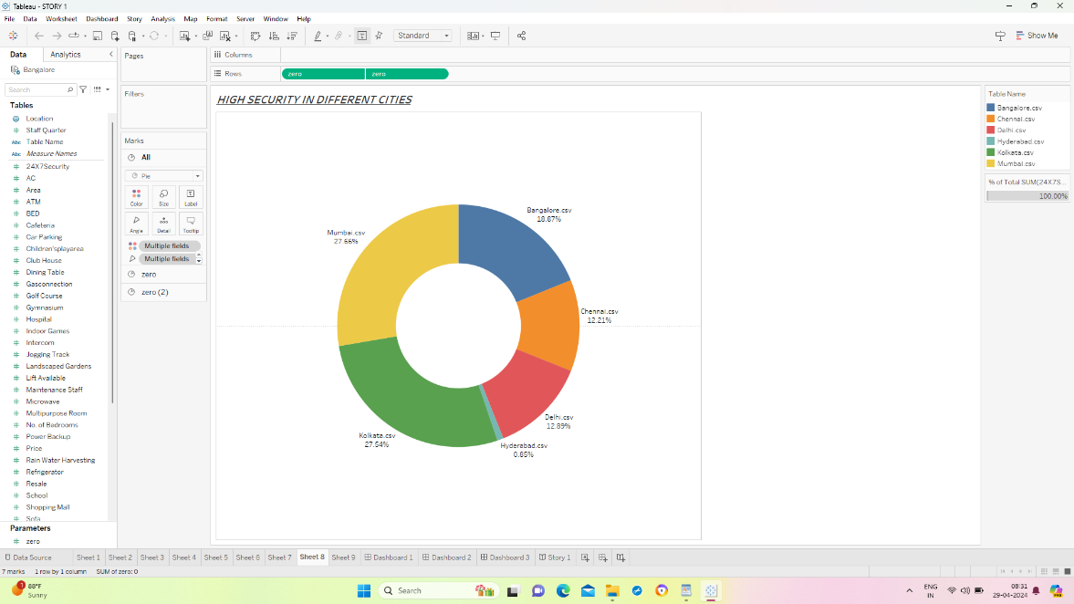

1. CIRCLE CHART :

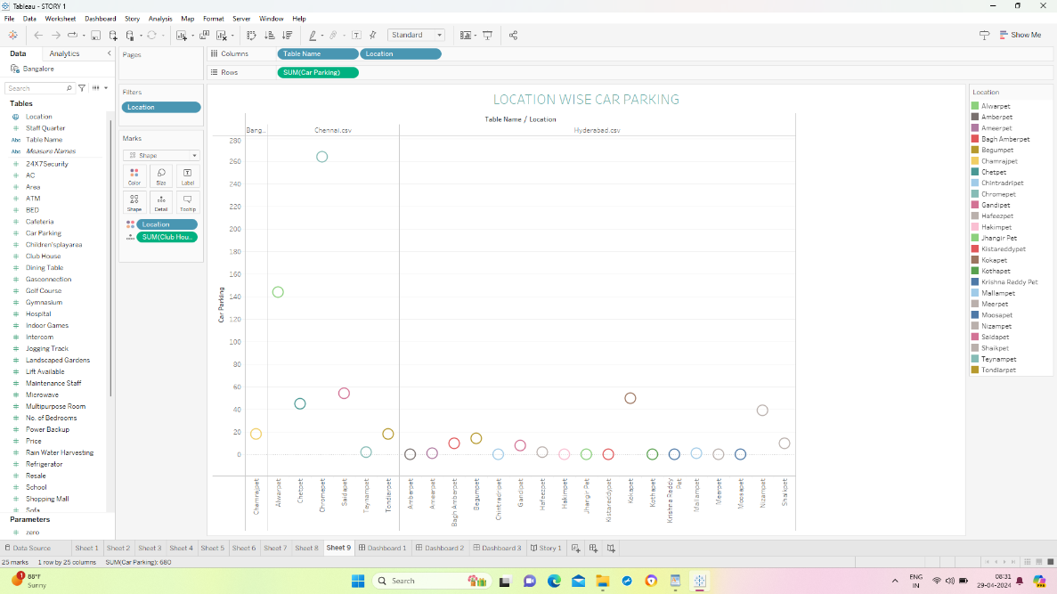

Here we conclude our visualization and next ….

**4. Dashboard :**

A dashboard is a graphical user interface (GUI) that displays information and data in an organized, easy-to-read format. Dashboards are often used to provide real-time monitoring and analysis of data and are typically designed for a specific purpose or use case. Dashboards can be used in a variety of settings, such as business, finance, manufacturing, healthcare, and many other industries. They can be used to track key performance indicators (KPIs), monitor performance metrics, and display data in the form of charts, graphs, and tables.

**Responsiveness And Design Of Dashboard**

Once you have created views on different sheets in Tableau, you can pull them into a dashboard.

DASHBOARD 1 :

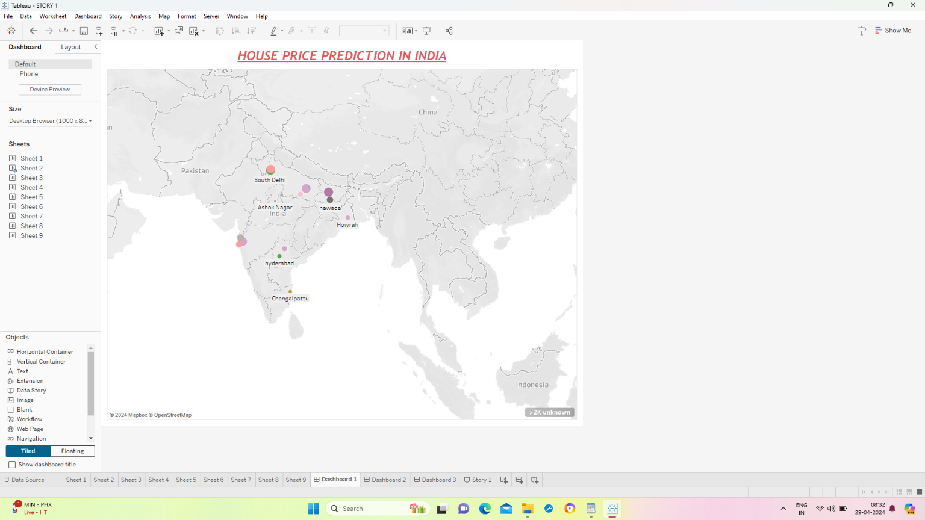

DASHBOARD 2:

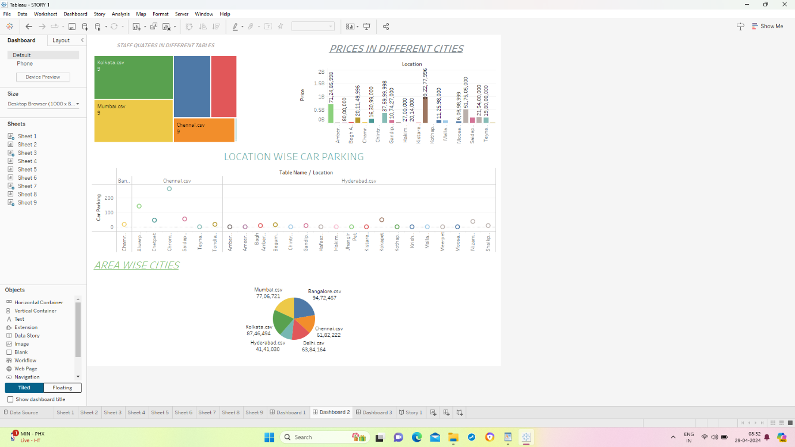

DASHBOARD 3 :

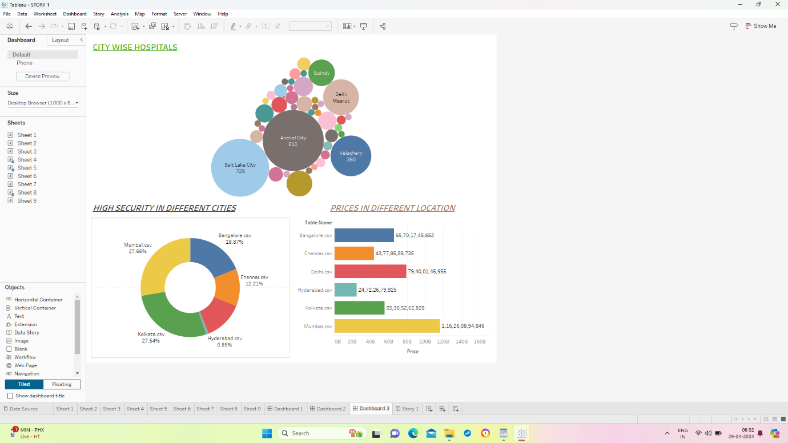

5. **Story**

A data story is a way of presenting data and analysis in a narrative format, intending to make the information more engaging and easier to understand. A data story typically includes a clear introduction that sets the stage and explains the context for the data, a body that presents the data and analysis logically and systematically, and a conclusion that summarizes the key findings and highlights their implications. Data stories can be told using a variety of mediums, such as reports, presentations, interactive visualizations, and videos.

**No Of Scenes Of Story**

The number of scenes in a storyboard for a data visualization analysis of the performance and efficiency of Radisson Hotels will depend on the complexity of the analysis and the specific insights that are trying to be conveyed. A storyboard is a visual representation of the data analysis process and it breaks down the analysis into a series of steps or scenes.

* 1. 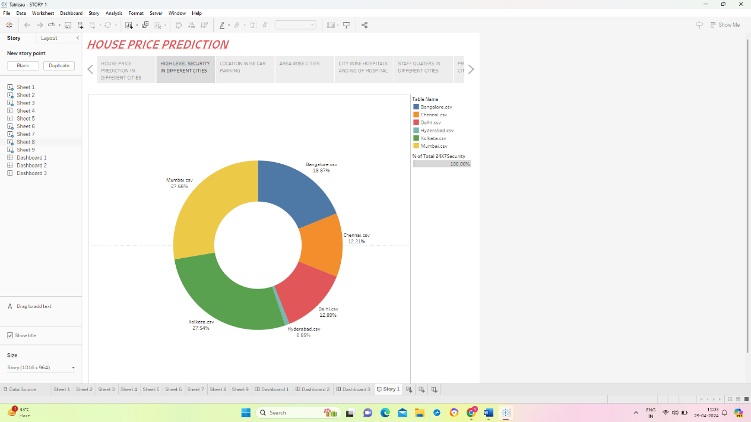
  2. 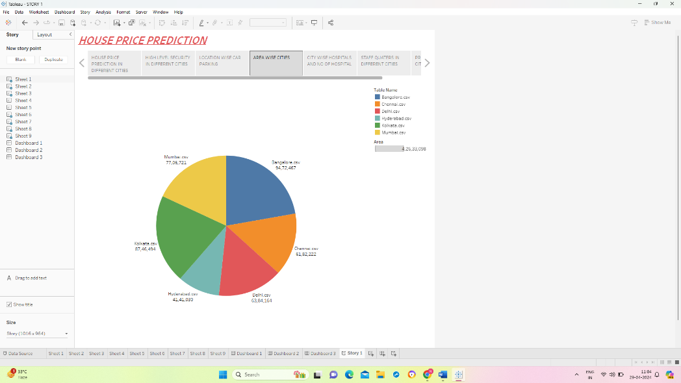
  3. 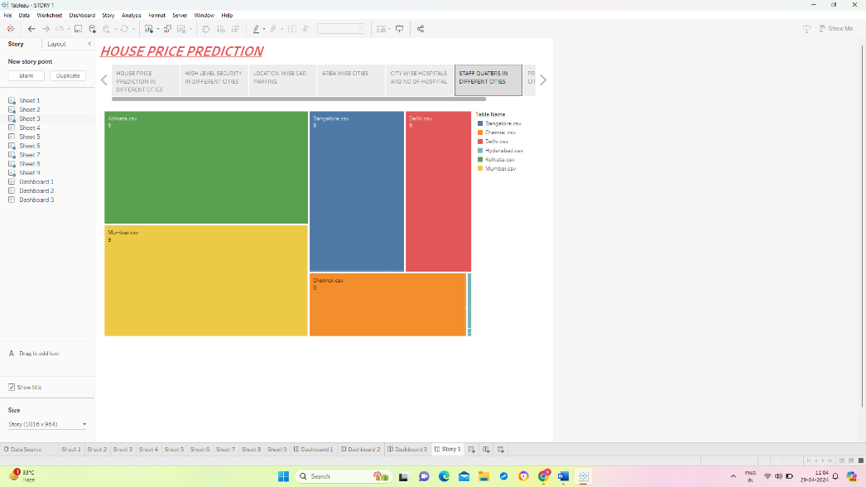
  4. 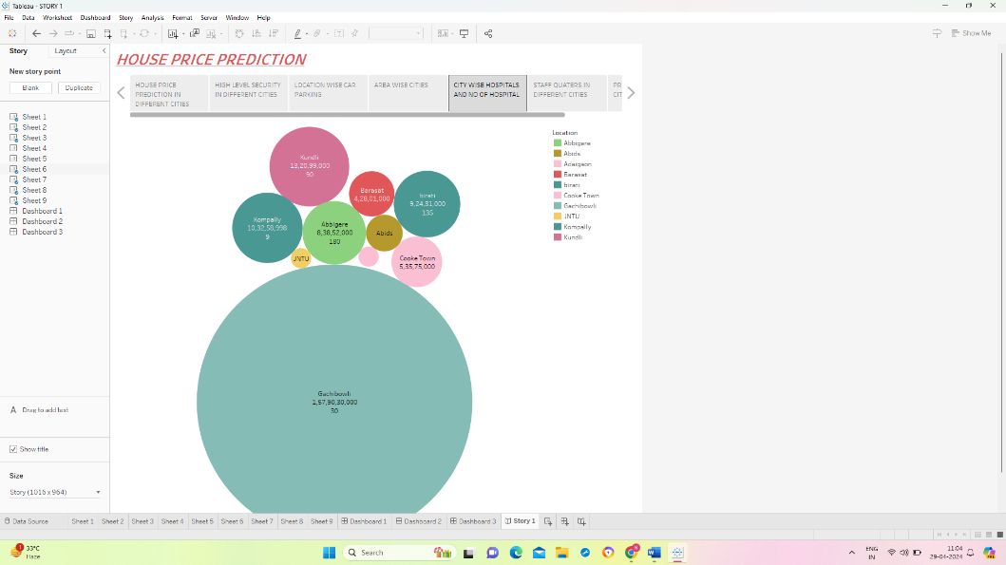
  5. 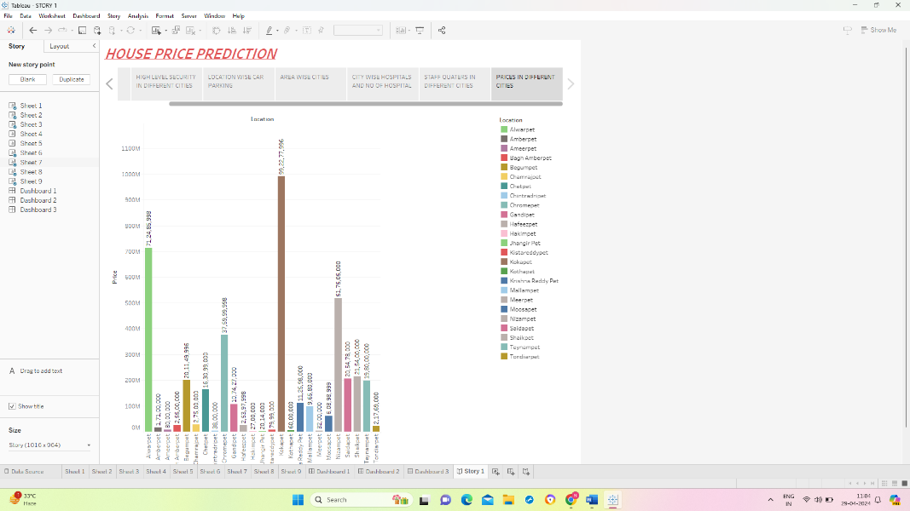
  6. **Web Integration**

Publishing helps us to track and monitor key performance metrics and to communicate results and progress. help a publisher stay informed, make better decisions, and communicate their performance to others.